
Optimization using central composite design (CCD) of response surface methodology (RSM) for biosorption of hexavalent chromium from aqueous media

The objective of this research paper is to remove hexavalent chromium from aqueous media through batch technique with the use of unmodified biosorbent from Arachis hypogea husk. Design of Experiments (DoE) methodology is applied in the optimization of the independent variables influencing the adsorption process.
The factors (independent variables) examined are: X₁ = contact time (min), X₂ = pH of solution and X₃ = initial Cr(VI) concentration (mg/L). All the factors are continuous. The response (dependent variable) examined is: Y = adsorption capacity (mg/g). The applied DoE method is Circumscribed Central Composite design.
Isalos version used: 2.0.6
Scientific article: https://link.springer.com/article/10.1007/s13201-020-01213-3??utm_source=other_website&error=cookies_not_supported&code=4479f6fd-9544-4729-b4c3-7bc34671094e

Step 1: Central Composite Design
In the first tab named “Action” define the factors in the column headers and fill each column with the low and high levels of the corresponding factors. This tab can be renamed “CCC”. Afterwards, apply the Circumscribed Central Composite method: DOE $→$ Response Surface $→$ Central Composite

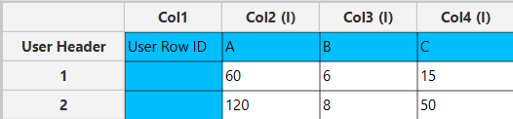

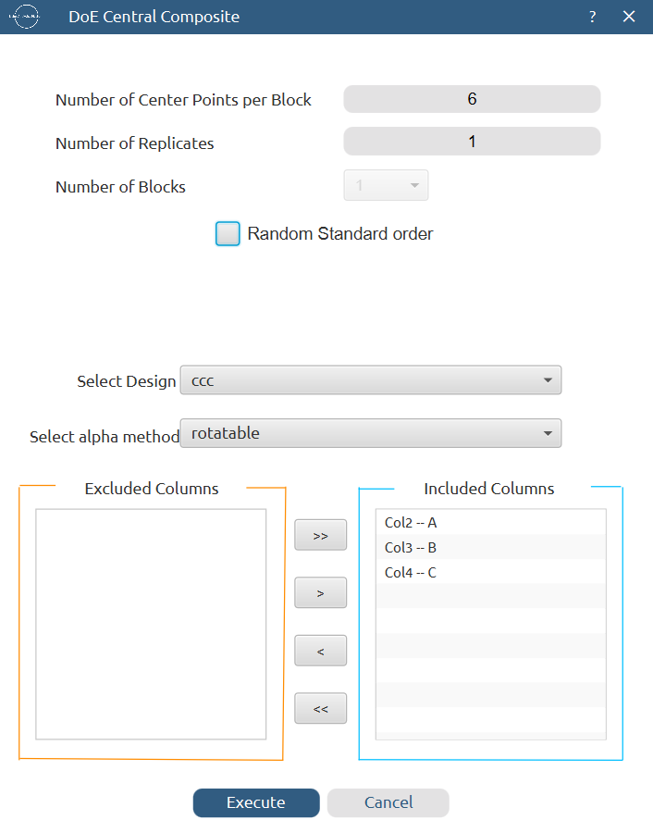

Results (right spreadsheet):
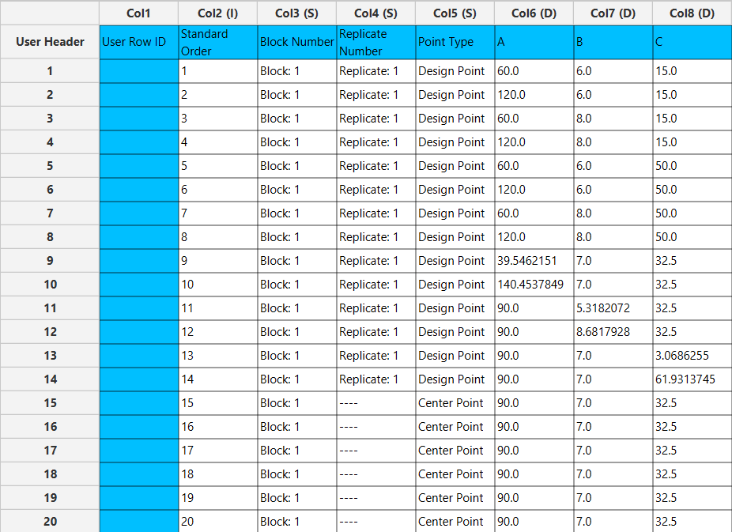

Step 2: Definition of response variables
Create a new tab named “Responses” and define the response in the column headers. Fill each column with the values of the response that was observed and make sure the values follow the order of the experiments as given by the Circumscribed Central Composite method. Then, select all columns to be transferred to the right spreadsheet: Data Transformation $→$ Data Manipulation $→$ Select Column(s)

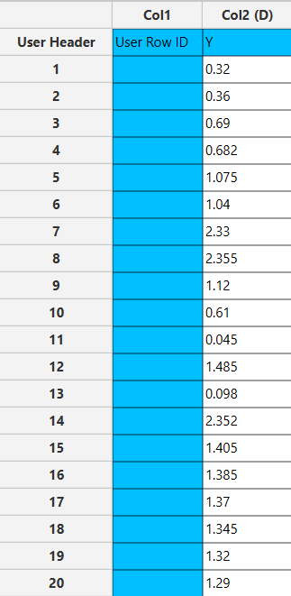

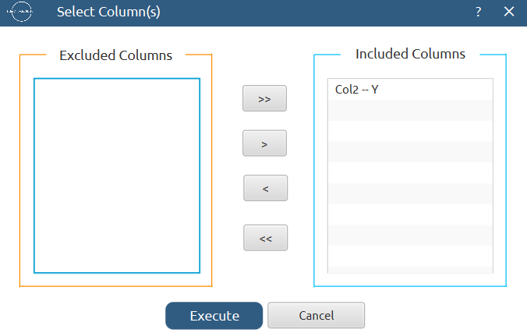

Step 3: Data isolation
Create a new tab named “Data” and import the results from the “CCC” and “Responses” spreadsheets by right clicking on the left spreadsheet. Then, select only the factors and responses columns to be transferred to the right spreadsheet: Data Transformation $→$ Data Manipulation $→$ Select Column(s)

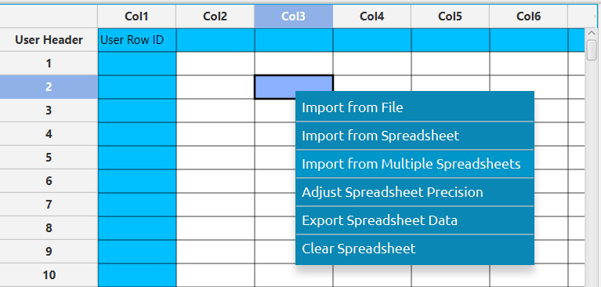

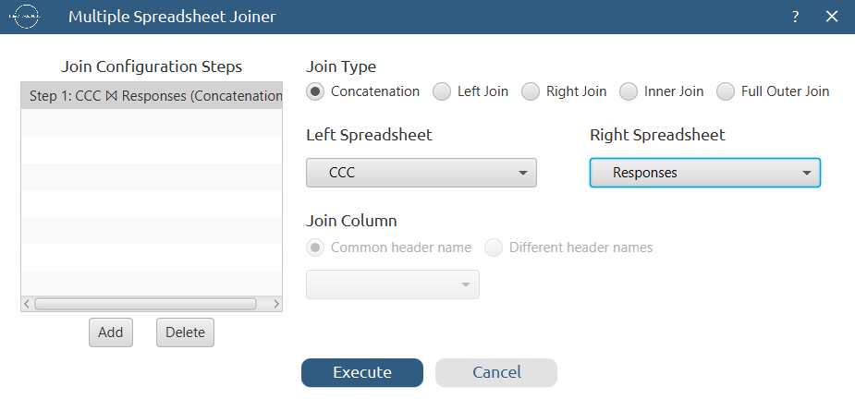

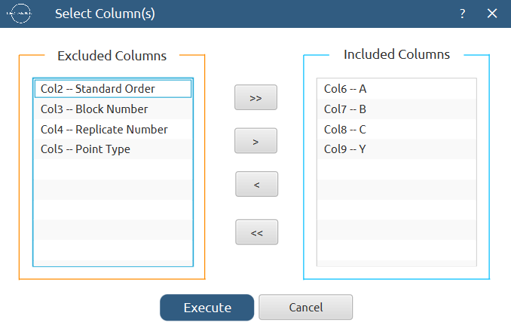
Results:
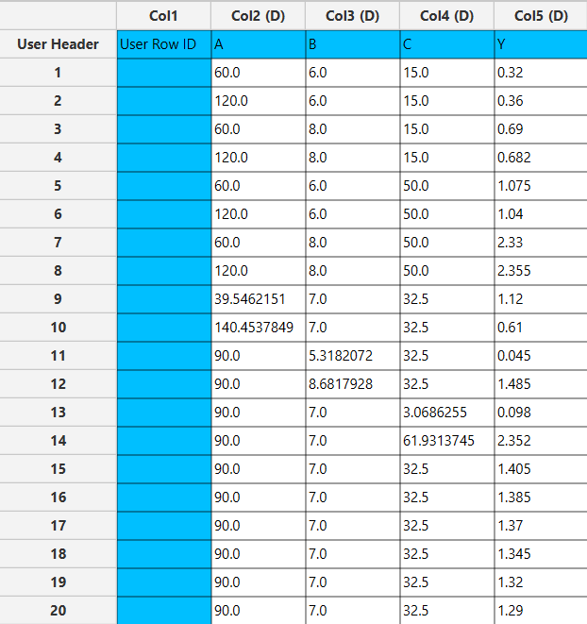

Step 4: Normalization
Create a new tab named “Normalized data” and import the results from the “Data” spreadsheet. Afterwards, normalize the factor columns to take values in the range [-1.682, 1.682]: Data Transformation $→$ Normalizers $→$ Min-Max



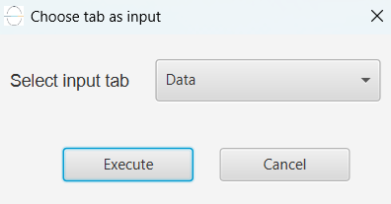

Results:
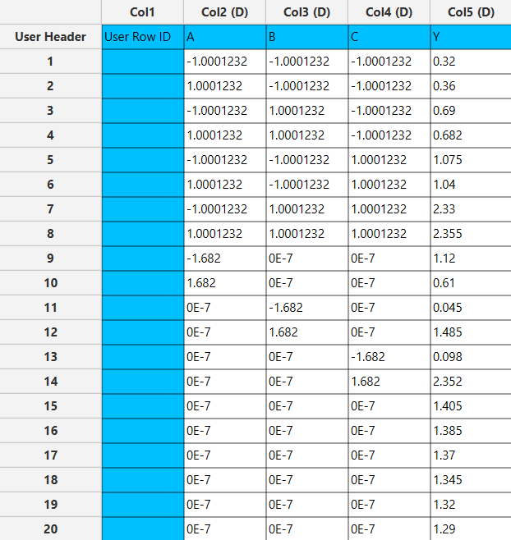

Step 5: Regression
The goal here is to produce a regression equation that includes main effects, two-factor interactions and quadratic effects for the response variable Y:
$$Y=b_{0}+b_{1}A+b_{2}B+b_{3}C+b_{12}AB+b_{13}AC+b_{23}BC+b_{11}A^{2}+b_{22}B^{2}+b_{33}C^{2}$$

Create a new tab named “Regression – Y” and import the results from the spreadsheet “Normalized data”. Afterwards, fit a generalized linear model to the data: Analytics $→$ Regression $→$ Statistical fitting $→$ Generalized Linear Models

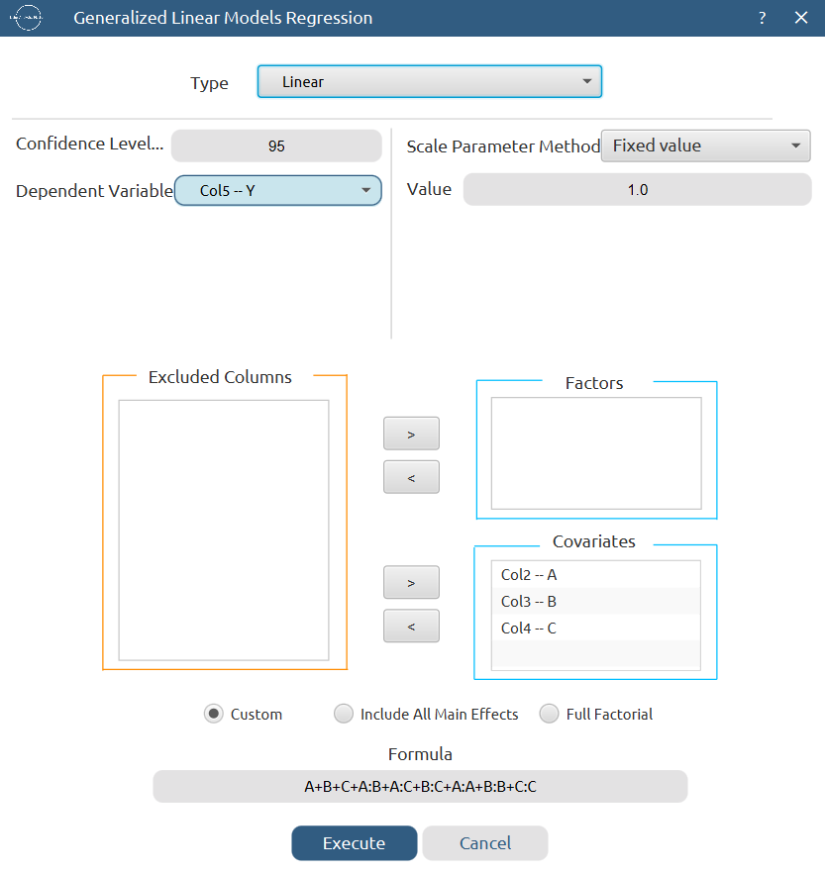

Results:

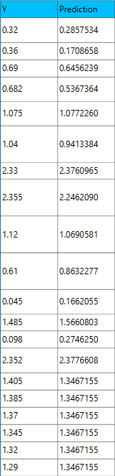
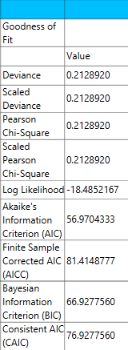

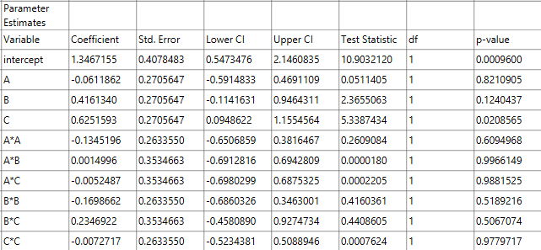

Step 6: Regression Metrics
Create a tab named “Metrics – Y” and import the results from the spreadsheet “Regression – Y”. Then, produce the regression metrics for the linear regression equation: Statistics $→$ Model Metrics $→$ Regression Metrics

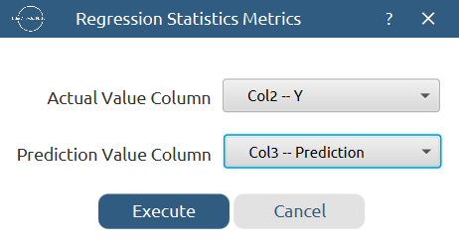

Results:
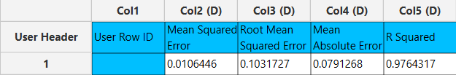

Step 7: Analysis of Covariance
Create a new tab named “ANCOVA – Y” and import the results from the spreadsheet “Normalized data”. Afterwards perform analysis of covariance for Y using the formula for the quadratic equation: Statistics $→$ Analysis of (Co)Variance $→$ ANCOVA
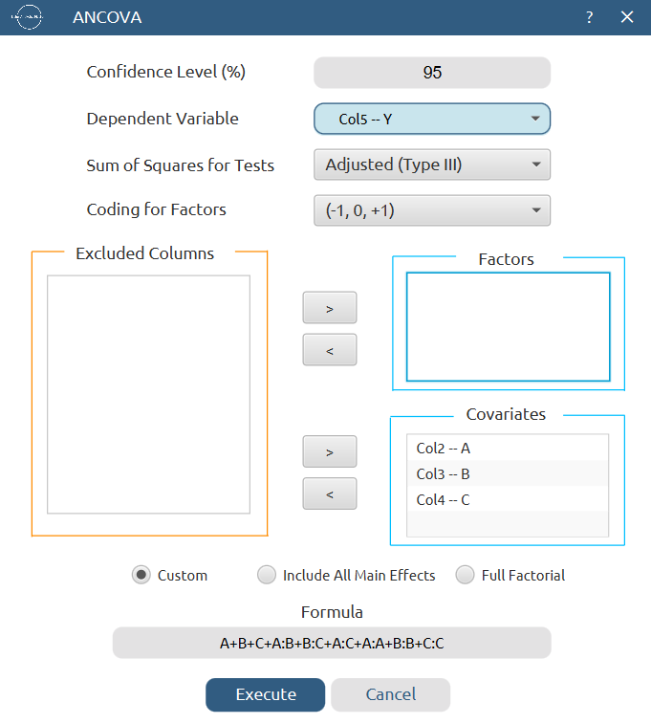

Results:
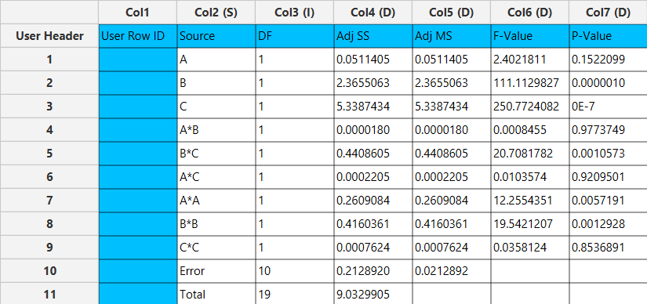

Final Isalos Workflow
The final workflow is presented below:
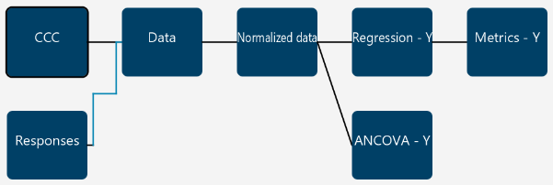

References
- Bayuo, J.; Abukari, M. A.; Pelig-Ba, K. B. Optimization Using Central Composite Design (CCD) of Response Surface Methodology (RSM) for Biosorption of Hexavalent Chromium from Aqueous Media. Appl Water Sci 2020, 10 (6), 135. https://doi.org/10.1007/s13201-020-01213-3.

